Computer graphics cat

Group members
- Fred kiboga : BSCCS/2023/60132
- Abdirahman aden:BSCCS/2023/61417
- Peter Mutuku :BSCCS/2023/72405
- Humslyng Salako BSCCS/2023/59234
- Abdiwahab Mahamud BSCCS/2023/60787
- Victor Kihanda BSCCS/2023/59553
- Sipitiek Saruni BSCCS/2023/72038
- Benjamin korir: BSCCS/2023/72733
- Johnson Ng'ang'a BSCCS/2023/61865
- Brian Mwangi BSCCS/2023/59275
- Abdirahman Abdullahi BSCCS/2022/58147
- Leaky Mawira BSCCS/2023/72109
- BSCCS/2023/60036- Osteen Muthike
A 14 FLOOR PLAN COMMERCIAL OFFICE LAYOUT
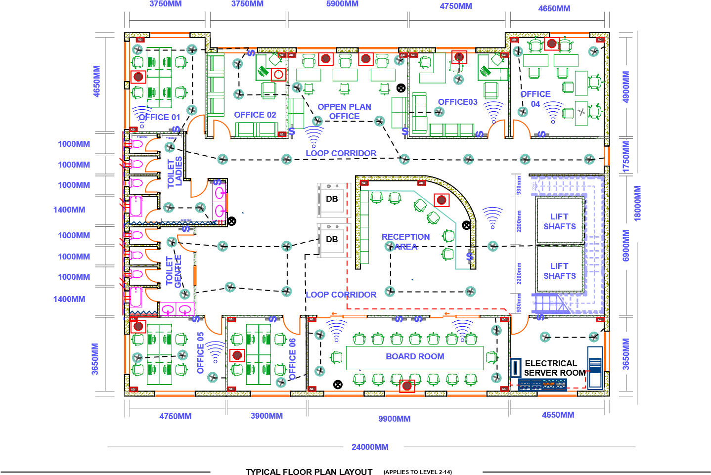
ELECRTICAL LEGEND |  | WATER & PLUMBING LEGEND | WI-FI & NETWORK LEGEND |  |  | Wall Type  Thickness  Externall Wall  Internal partition wall  250  mm  100  mm  Door  Window  Width  Height  900  mm  2100  mm  2000  mm  mm  1500 | 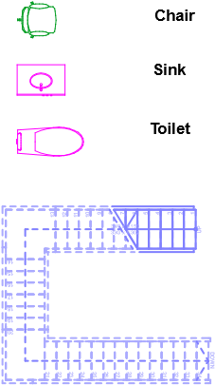 | Stair  Case | MOUNT KENYA UNIVERSITY  School: computing & Information Technology  Course Code: BIT4102/Computer Graphics Scale: 1:100  Drawing Title : TYPICAL FLOOR PLAN Assessment Type: Practical (CAT)  CAT NO: FINAL CAT
s  DB  DB | wall switch  ceiling LED Light  Distribution Board  Double Socket Outlet  Main Power Supply Electrical Wiring | Main Water Riser Cold Water Line  Vertical Drain  Basins | Data Point Socket  Wi-fi
Network Rack (42U)
WI-FI Access Point (AP-01)

